**<https://github.com/mananvijay7/Medical-Prescription-Delivery-System-DMDD-Group14>  
  
DATA MANAGEMENT AND DATABASE DESIGN** **PROJECT-P2** **DATABASE DESIGN DOCUMENT**

**Medical-Prescription-Delivery-System-Group14**

**Project Description:**The Medical Prescription Delivery System integrates with existing healthcare management systems to create a comprehensive database management system for medical prescriptions. This system allows patients to view and place prescription orders online, browse medication options, customize their orders with dosage and quantity specifications, and securely pay for their prescriptions. The platform also supports generating reports on total prescriptions filled per day.

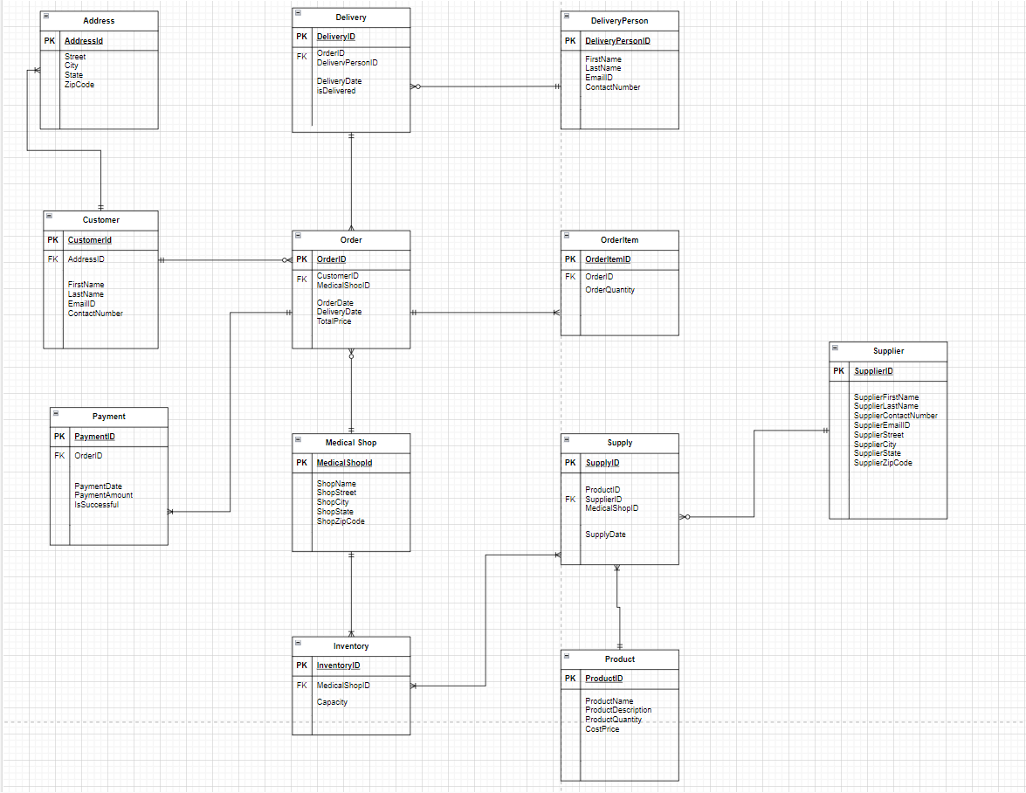

**Key Database Design Decisions**:

**Entities**:

**Customer**: Places prescription orders through the online application.

**Medical Shop**: Accepts orders from Customers and is responsible for the delivery.

**Catalog**: Consists of all available medications, allowing patients to browse through options.

**Medication Item**: Specific medications available for order.

**Order**: Placed by the patient and processed by the pharmacy.

**Order Item**: Specific quantity and dosage of the medication being ordered.

**Payment**: Made by the patient to the pharmacy through the app.

**Delivery**: Delivery of the medication order to the patient.

**Delivery Person**: Delivers the order from the pharmacy to the patient.

**Transactions**: Records the number of prescriptions filled and tracks pharmacy

growth.

**Inventory**: Stocks medication to be supplied to the pharmacy.

**Supplier**: Supplies medication from the inventory to the pharmacy.

**Supply Record**: An associative entity that records the transactions between the supplier and pharmacy.

Relationship:  
Address to Customer: One-to-One (Mandatory to Mandatory) - Each customer has one unique address, and each address is associated with a single customer.

Customer to Order: One-to-Many (Mandatory to Optional) - A customer can place multiple orders, but each order is linked to a specific customer.

Order to OrderItem: One-to-Many (Mandatory to Optional) - An order may consist of several order items, with each item being part of one order.

Order to Payment: One-to-One (Mandatory to Mandatory) - Each order is associated with a single payment, and each payment corresponds to a specific order.

Order to Delivery: One-to-One (Mandatory to Mandatory) - Each order must have a corresponding delivery instance, and every delivery corresponds to one order.

Delivery to DeliveryPerson: Many-to-One (Optional to Mandatory) - A delivery person may be responsible for multiple deliveries, but each delivery is assigned to one delivery person.

Medical Shop to Order: One-to-Many (Mandatory to Optional) - A medical shop may fulfill multiple orders, and each order is filled by a single medical shop.

Medical Shop to Supply: One-to-Many (Mandatory to Optional) - A medical shop may receive multiple supplies, with each supply coming from one supplier.

Supplier to Supply: One-to-Many (Mandatory to Optional) - A supplier can provide multiple supplies, with each supply being linked to one supplier.

Supply to Product: One-to-Many (Mandatory to Optional) - A supply can contain multiple products, and each product is part of a supply.

Medical Shop to Inventory: One-to-One (Mandatory to Mandatory) - Each medical shop has one inventory, and each inventory is managed by one medical shop.

Inventory to Product: One-to-Many (Mandatory to Optional) - Inventory holds multiple products, with each product being a distinct item within the inventory.

**Business Problems Being Addressed:**

**Real-time Order Management:** Enables pharmacies to manage all incoming prescription orders efficiently.

**Customer Information Management:** Allows for a more personalized healthcare experience by managing patient information, including contact details and prescription history.

**Security:** Ensures the privacy and integrity of patient data.

**Analytics and Reporting:** Provides pharmacies with detailed insights into operations, helping them make informed decisions regarding inventory management and patient care.